PRESS INFORMATION

Striking EWR130E rewrites the rulebook on compact performance

With the shortest swing radius, class leading stability and operator renowned cab, Volvo CE’s EWR130E establishes a new standard in wheeled excavator performance in the 12-13 tonne class.
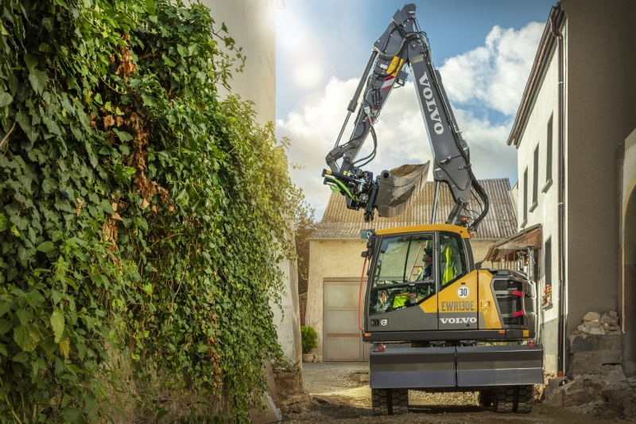
‘Compact’ is almost too long a word to describe the new EWR130E. So tight are its dimensions that its rear, at just 1.55m (5’ 1”), and front swing, at only 1.81m (5’ 11”), gives the shortest swing in the 12-13 tonne class that it joins. The closely packaged machine is a first on many levels and has been designed from a clean sheet of paper, with extensive customer input. The result is a machine that is extremely maneuverable yet offers excellent lifting performance, digging force, application flexibility and operator visibility. Oh, and not forgetting spacious comfort and ease of use.

Confined worksites welcomed
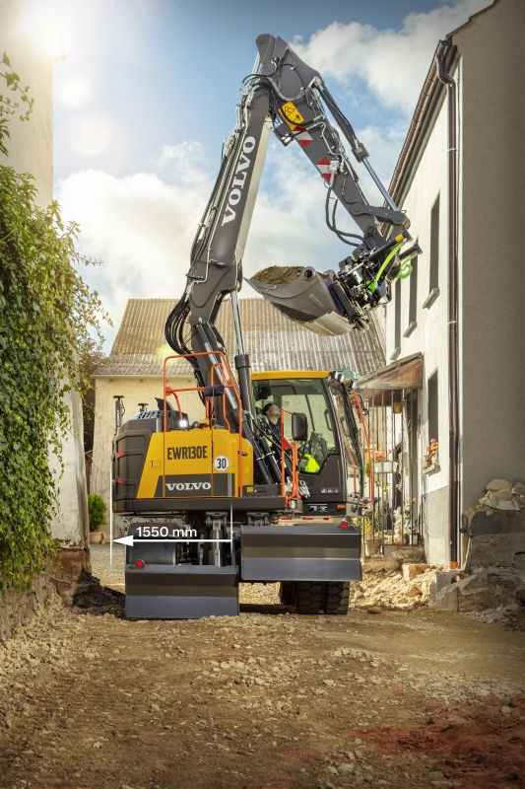
With such modest dimensions, the new EWR130E allows the operator to work in even the most confined jobsites the urban world can throw at it. And it’s not just in town the EWR130E makes sense, but on roads where traffic safety is paramount and – such is its performance – even on larger infrastructure projects. It’s also so light-footed that it can even be used on landscaping projects. But it’s the ability to get into a tight corner that is its real ace card – a hand improved still further thanks to its two-piece boom and inline outriggers. These new outriggers help position and stabilize the machine when there’s not an inch to spare either side of the machine.

The EWR130E is instantly recognizable as the confident little brother of the EWR150E and EWR170E wheeled excavators. However, its clever positioning sets it apart from any other machine in the market. This is because it benefits from the compactness of a smaller 10 tonne machine yet provides the performance of a 13+ tonner.

The EWR130E boasts a considerably lower center of gravity compared to equivalent machines, resulting in unbeatable stability. The two-piece, non-pivoting boom enables lifting up to 4.3t (9,480 lb) at a 6-meter (19.7 ft) reach. This smartly designed digging equipment, combined with the respected D4 Volvo engine, delivers best-in-class breakout force and superior tear-out force.

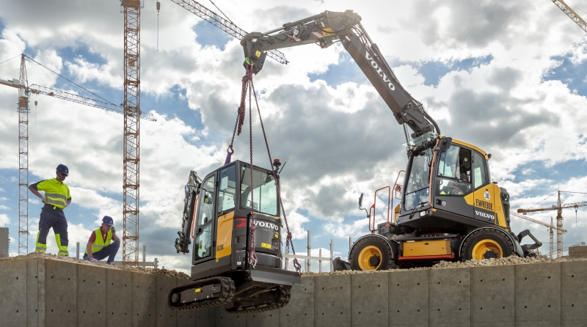

New features add to machine flexibility and maneuverability
Two exciting new options on the EWR130E are the four-wheel steering and divided blades. The four-wheel steering improves maneuverability still further by reducing the turning radius. This, and a range of other steering modes are selected from the cab using a rotary dial. The divided blades, meanwhile, offer more options for leveling the machine on uneven ground or around curbs etc.
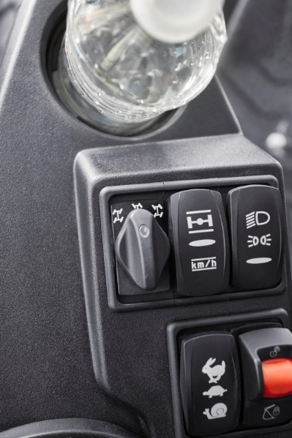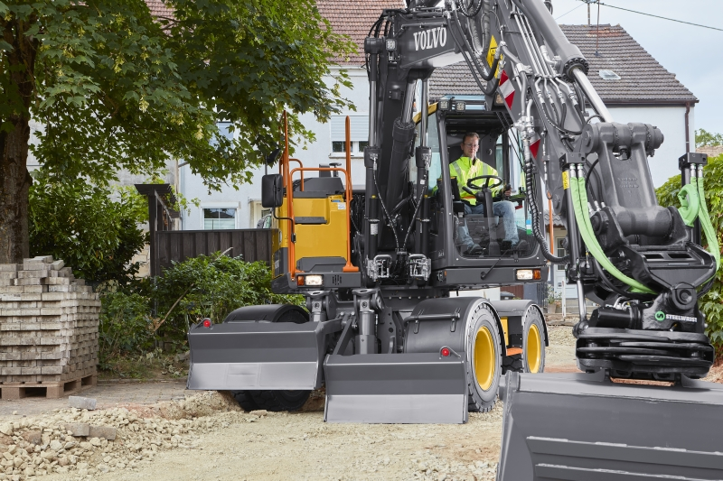

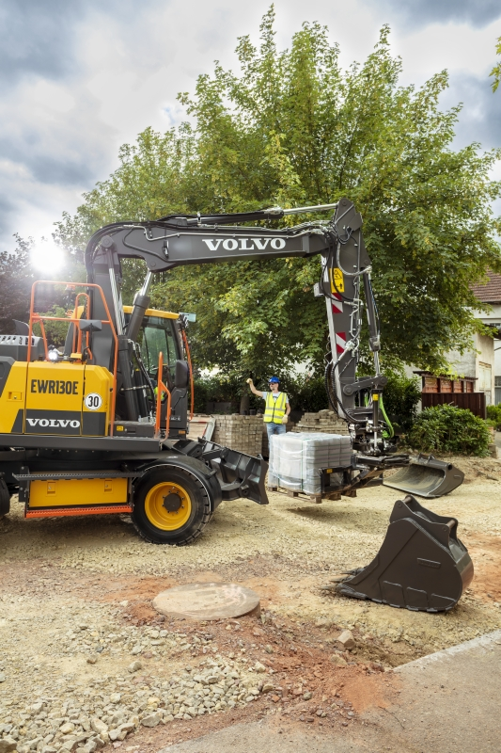
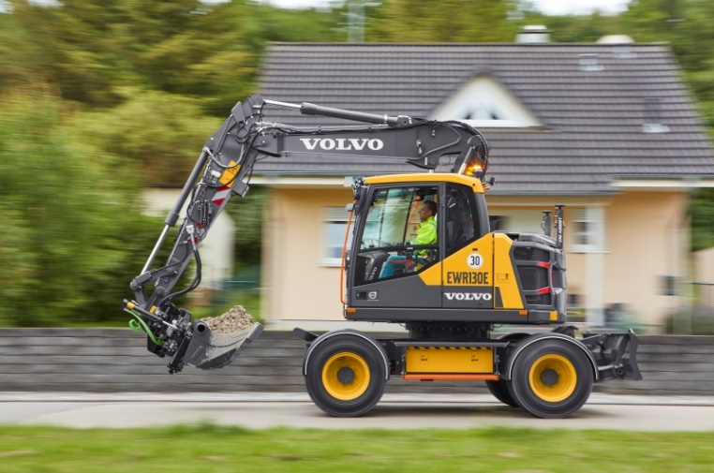
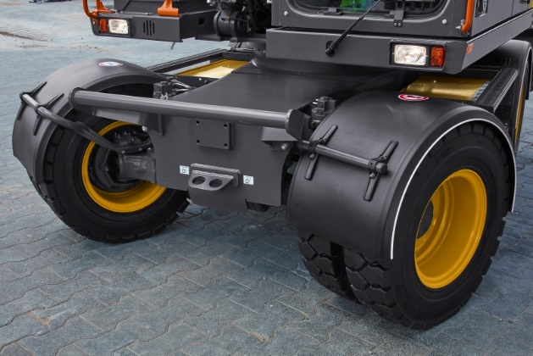
The EWR130E is an exceptionally versatile machine, helped by the easy attachments setup. The pressure and flow for up to 32 attachments can be preprogrammed without the need for a service technician. Connecting to hydraulic attachments can also be made from the cab, thanks to the Steelwrist Auto Connect Coupler. Steelwrist tiltrotators offer much improved tool flexibility at a wide range of angles, while the factory-fitted preparation system enables the Steelwrist tiltrotator to be controlled using the original joysticks, and operator profiles set up on the main display.

Like all wheeled excavators, the EWR130E can drive independently from one jobsite area to another. With travel speeds up to 35km/hr (22 mph) it is no slowcoach, and its Boom Suspension System engages at speeds above 5km/hr (3 mph) to absorb shocks and reduce bouncing over rough or bumpy terrain. While the optional axle mounted mudguards help keep the machine clean, the Comfort Drive Control function allows the excavator to be steered while on jobsites using just the joystick, at speeds up to 20km/hr (12mph.). And thanks to a TuV approved tow hitch the EWR130E can pull a trailer weighing 3 tonnes (6,600 lbs) – or 8 tonnes (17,600 lbs) when fitted with additional overrun brakes.

When driving is not practical, the EWR130E’s low machine height, combined with optimized tie-down points on the lower frame, makes machine transportation fast and easy.

When you get to the work area, the machine is ready for action right away, with the automatic digging brake engaging whenever the machine’s speed is zero. Help is at hand digitally too, with the optional Dig Assist machine control system offering 2D, In-Field Design, 3D excavation software and new On-Board Weighing apps, all displayed on the 10 inch Volvo Co-Pilot tablet, and making digging more accurate and faster.
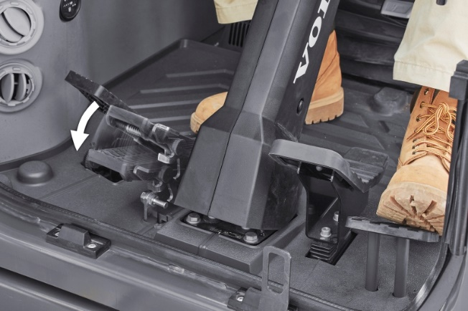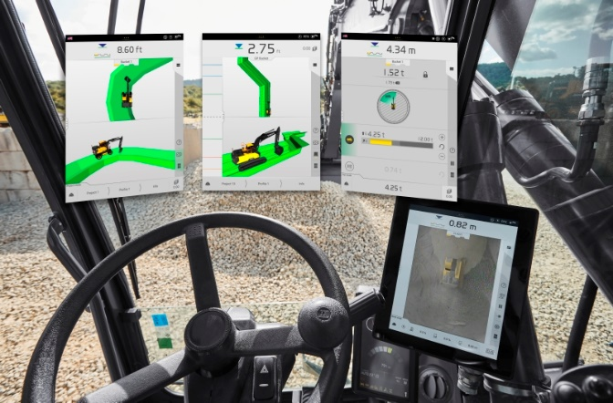

A room with a (great) view
Just because the machine is compact doesn’t mean the cab is. The EWR130E boasts a work environment for the operator that is just as spacious as on full-sized excavators. Controls are laid out ergonomically, comfort levels and most crucially – visibility – is outstanding. This is due to the low superstructure and design of the counterweight, hood and doors, which enhance visibility to the rear of the machine. Visibility to the right of the machine is best-in-class, due to no parts blocking the view out of the right-side window, a design concept unique to Volvo. And if you want complete 360 degree visibility, then opt for Volvo Smart View – three cameras attached to the frame that combine to create a bird’s eye view of the machine, visible on the in-cab color monitor.
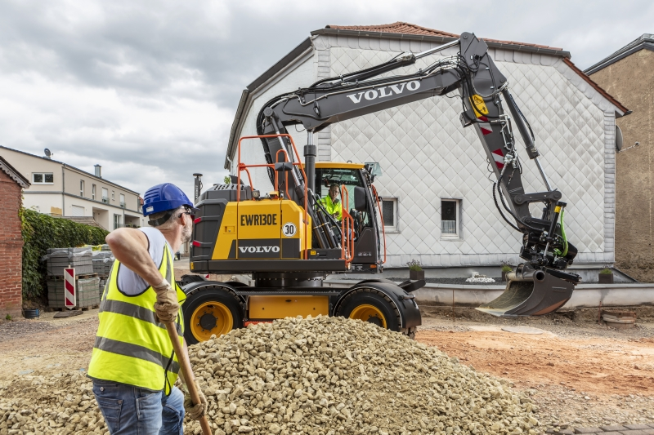

Joysticks can handle nearly all functions, from steering to window wiper operation. Programmable buttons allow operators to switch functions at the flick of a switch. As an option, the advanced L8 joystick is fully adjustable to any angle, thanks to a special ball joint, to offer the best ergonomic fit.
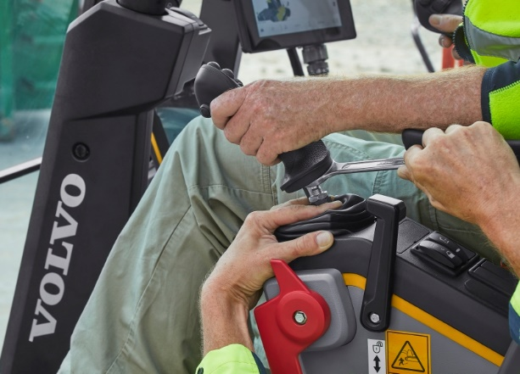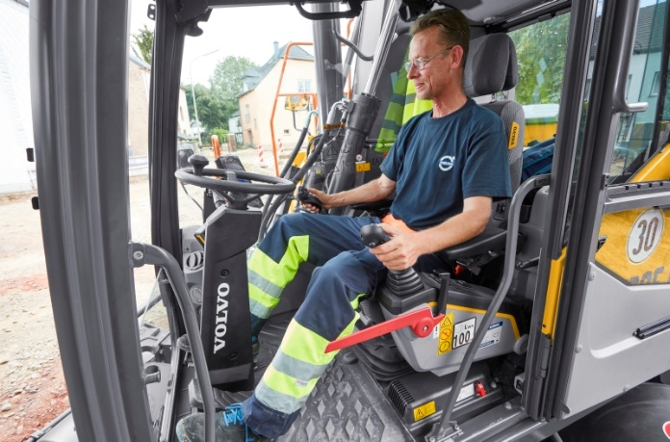

Other conveniences include a drawer-type toolbox for carrying tools, chains etc. It can carry up to 120 kg (265 lb) and features box dividers, which can be adjusted into five different positions, to help the operator stay organized. The excavator also features high visibility steps and handrails as well as a range of optional LED light packages, including the welcome light – guiding operators when entering and exiting the machine.
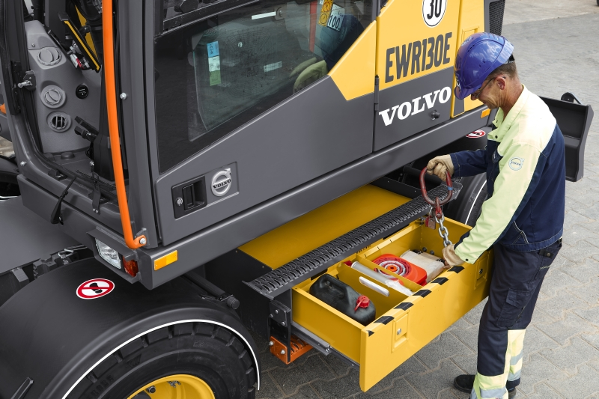

Taking care of the machine is taken care of
Servicing is made easy thanks to grouped greasing points and easy-to-reach filters, with all daily service checkpoints accessible from ground level. That’s not all, the pivoting air conditioning condenser is fixed with a flexible latch, improving access to the radiators, for easy cleaning and increased component life.
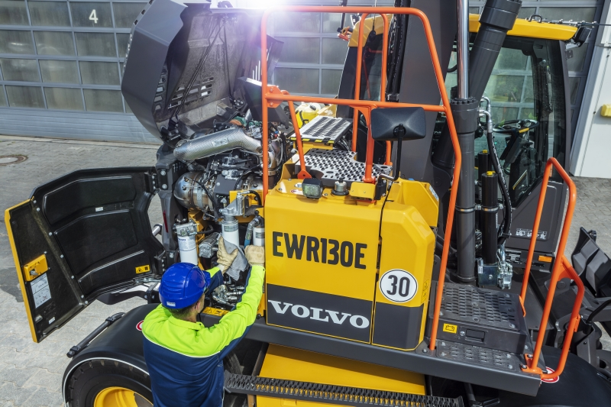

The EWR130E comes fitted as standard with the CareTrack telematics system. Accessed remotely, CareTrack provides machine information such as geolocation, fuel consumption and service reminders that allow improved planning and operation. Monitor the machine yourself, or allow Volvo Uptime Centers to provide 24/7 oversight, supplying weekly reports and providing notifications if action is required, with Volvo Active Care.

With so much ingenuity crammed into a small space, the all-new EWR130E from Volvo is the new benchmark for others to beat.

Key specifications EWR130E:

Engine EPA Tier 4 final! EU stage V |  | Volvo D4J
Operating weight  4,85 m fixed two piece boom with 2,1 m arm, Camso single tires 500/45-20 and standard parallel blade rear | kg | 12 900
 | lb | 28,44
Operating weight  4,85 m fixed two piece boom with 2,4 m arm , 9 inch Mitas twin tires front divide blade and rear outriggers and 4 wheel steering | kg | 14 400
 | lb | 31,75
Gross power | kW | 90
 | Hp(imp) | 120
. at engine speed | r/min | 2000
Max. reach ( 2,1 m —2,4 m arm ) | m | 8,44 - 8,67
 | ft | 27.7' - 28.5'
Max speed | km/h | 20/30/35
 | mi/h | 12.4/18.6/21.7

Ends.
November 2020
For further information, please contact:

Åsa Alstrom | Brian O’Sullivan
Head of Strategic Communication | SE10
Volvo Construction Equipment | London
Email: asa.alstrom@volvo.com | Tel: int +44 77 333 50307
 | Email: osullivan@se10.com
Follow us on social media:
@VolvoCEGlobal

@VolvoCEGlobal
@Volvo Construction Equipment
@globalVolvoCE

Volvo Construction Equipment (Volvo CE) is a leading international manufacturer of premium construction equipment, and with over 14,000 employees, it is one of the largest companies in the industry. Volvo CE offers a wide range of products and services in more than 140 countries through its global distribution network. Volvo CE is part of the Volvo Group. The Volvo Group drives prosperity through transport solutions, offering trucks, buses, construction equipment, power solutions for marine and industrial applications, financing and services that increase our customers’ uptime and productivity. Founded in 1927, the Volvo Group is committed to shaping the future landscape of sustainable transport and infrastructure solutions. The Volvo Group is headquartered in Gothenburg, Sweden, employs 105,000 people and serves customers in more than 190 markets. In 2018, net sales amounted to about SEK 391 billion (EUR 38.1 billion). Volvo shares are listed on Nasdaq Stockholm.

SS

@Volvo Construction Equipment

